Web Application Testing – REST API Endpoints

Create java class to write test cases under test folder in src

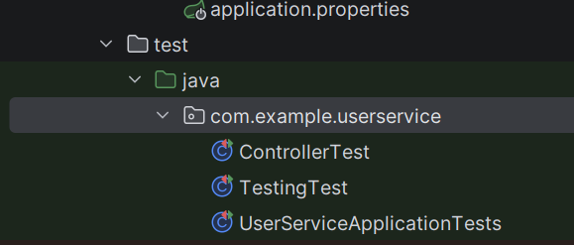
test folder java folder package class TestingTest
----------------------------
- @SpringBootTest is a Spring Boot testing annotation used to load the complete application context while running tests.
- MockMvc is a core part of the Spring Test framework used to test server-side Spring MVC controllers without running a real web server. It simulates HTTP requests and responses, allowing developers to verify controller logic, HTTP status codes

@AutoConfigureMockMvc
@SpringBootTest
public class TestingTest {
// testcases
}
--------------------------------
TestingTest.java
package com.example.userservice;
import org.junit.jupiter.api.Assertions;
import org.junit.jupiter.api.Test;
import org.springframework.beans.factory.annotation.Autowired;
import org.springframework.boot.test.context.SpringBootTest;
import org.springframework.boot.webmvc.test.autoconfigure.AutoConfigureMockMvc;
import org.springframework.test.web.servlet.MockMvc;

import static org.springframework.test.web.servlet.request.MockMvcRequestBuilders.get;
import static org.springframework.test.web.servlet.result.MockMvcResultMatchers.*;

@SpringBootTest
@AutoConfigureMockMvc
public class TestingTest {
@Autowired
private MockMvc mockMvc;
// Validating the API
@Test
public void testExample() throws Exception
{
mockMvc.perform(get("/api/users")).andExpect(status().isOk());
}

//Test the API to check the value of the response
@Test
public void getUserResponse() throws Exception{
mockMvc.perform(get("/api/users"))
.andExpect(status().isOk())
.andExpect(content().contentType("application/json"))
.andExpect(jsonPath("$.length()").value(2))
.andExpect(jsonPath("$[0].name").value("BP"));
}

//Testing the API for Structure of the response
@Test
public void structureTesting() throws Exception{
mockMvc.perform(get("/api/users"))
.andExpect(jsonPath("$[0].email").exists())
.andExpect(jsonPath("$[0].name").exists());
.andExpect(jsonPath("$[0].userId").doesNotExist());
}

}

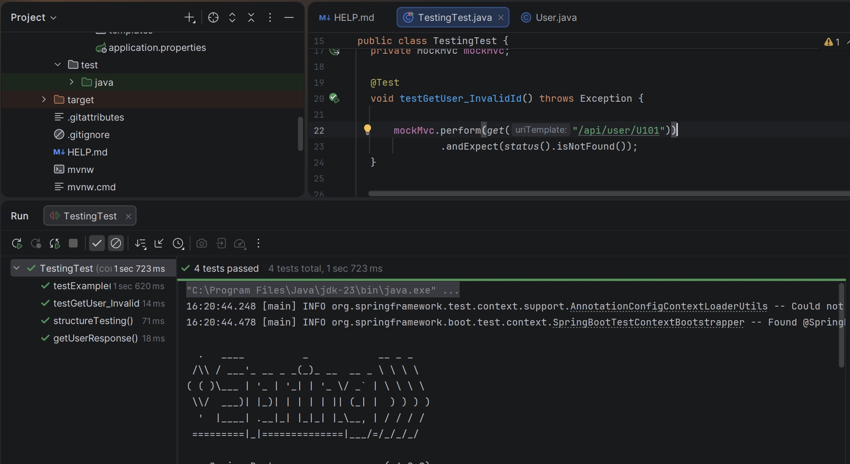

Web Application Testing – Navigation testing of Endpoints

